

**A PROJECT REPORT ON**

# Automobile Accessories Delivery Website

**Submitted in partial fulfillment for Degree of**

**MASTER OF COMPUTER APPLICATION**

**By**

**Kaustubh Gangadhar Parab**

**Under the guidance of**

**Prof. Ravindra Kerkar (Department of MCA)**

**Submitted to**

**Department of MCA**

**FINOLEX ACADEMY OF MANAGEMENT AND**

# TECHNOLOGY, RATNAGIRI



**FINOLEX ACADEMY OF MANAGEMENT AND TECHNOLOGY, RATNAGIRI**

**This is to certify that the project report titled:**

## Automobile Accessories Delivery Website

**Submitted By:**

**Mithil Suresh Pawar**

**Kaustubh Gangadhar Parab****Deepak Jagannath Pirankar**

**In partial fulfillment of the award for degree of**

# MASTER OF COMPUTER APPLICATION

**From Mumbai University**

## And is/are the bonafide records of the work done by him/her/them during the Semester I of A.Y 2023-2024

**Internal Guide HOD Principal**

**(Prof. Ravindra Kerkar) (Prof. Tejas V. Joshi) (Dr. Kaushal K. Prasad)**

## ABSTRACT

The "Automobile Accessories Delivery Website" project is a dynamic digital platform aimed at revolutionizing the automobile accessory procurement process. This project encompasses the creation of an intuitive and user-friendly online portal that facilitates the seamless purchase and delivery of a wide array of automotive accessories to customers' doorsteps.

Through meticulous planning and innovative development methodologies, this project focuses on bridging the gap between automobile enthusiasts and high-quality accessories. The website integrates advanced functionalities to enhance user experience, including streamlined browsing, secure payment gateways, order tracking, and personalized recommendations.

This abstract encapsulates the essence of a comprehensive project that not only addresses the specific needs of automobile accessory consumers but also sets a benchmark for user-centric digital solutions in the automotive industry. The project's success is a testament to the amalgamation of technical expertise, strategic planning, and unwavering dedication to delivering excellence.

**ACKNOWLEDGEMENT**

It gives us immense pleasure to present the report of our project here. It has been quite an experience, facing several problems at stages and coming up with appropriate solutions, at times the discussion amongst us or suggestions from our friends and teachers.

We thank our guide Prof. Minaxi Gurav, Department of Master of Computer Application, in the best possible way. Without her guidance, it wouldn’t have been possible to reach this stage. We are very grateful for his support and motivation.

We express our gratitude to Prof. Tejas V. Joshi, Professor and Head of the Department, Master of Computer Application for his invaluable suggestions and constant encouragement.

Lastly, we would like to put our thanks on record to the teaching and non-teaching staff for rendering their support directly or indirectly.

## BUSINESS CASE

1. Executive Summary:

The proposed project involves the establishment of an online platform dedicated to automobile accessories. The goal is to create a user-friendly website that provides a wide range of accessories for various vehicles. This initiative aligns with the organization's strategy to expand its online presence and cater to the growing demand for automotive customization.

1. Introduction:

This section introduces the business case, outlining the intention to create an online platform that simplifies the purchase of automobile accessories. The website aims to offer a diverse range of products, creating a centralized hub for automotive enthusiasts and vehicle owners.

1. Statement of the Problem:

The current lack of a dedicated online platform for automobile accessories poses a challenge for vehicle owners seeking convenient and diverse options. This gap in the market restricts the organization's ability to tap into the growing e-commerce trend for automotive products.

1. Analysis:

To address the identified problem, a detailed analysis has been conducted, considering market trends, customer preferences, and the organization's strategic objectives. Market research indicates a rising demand for online platforms specializing in automobile accessories. The absence of such a platform can potentially impact the company's revenue and market share.

1. Discussion of Possible Options:

Benefits:

Market Expansion: The development of an online platform provides an opportunity to tap into the growing e-commerce market for automobile accessories, reaching a broader audience.

Brand Visibility: The website serves as an additional touchpoint for customers, enhancing brand visibility and potentially attracting new customers who value the convenience of online shopping.

Costs:

Development Costs: Initial investment is required for website development, including platform design, user interface, and e-commerce functionality.

Maintenance Expenses: Ongoing costs for website maintenance, updates, and technical support.

Time-scale:

Development Time: Anticipate a six-month timeline for website development, ensuring a thorough testing phase for a seamless user experience.

Return on Investment: Expect a return on investment within the first year, as the platform gains traction and customer engagement increases.

Risks:

Competition: The online automotive accessories market is competitive; the risk of competing with existing platforms for market share exists.

Technical Challenges: Potential challenges during the development phase, such as technical glitches or delays, could impact the project timeline.

6. Recommendation:

Considering the potential benefits, market demand, and strategic alignment, the recommendation is to proceed with Option 1: Develop an Automobile Accessories Website. While there are initial costs and potential risks, the long-term advantages in terms of revenue generation and market positioning outweigh the drawbacks.

## TABLE OF CONTENT

|  |  |  |
| --- | --- | --- |
| Sr no | Content | Page No |
| **1.** | **Introduction** | 10 |
|  | 1.1 Background | 10 |
|  | 1.2 Objectives | 10 |
|  | 1.3 Purpose, Scope and Applicability | 11 |
| **2.** | **Survey Of Technologies** | 12 |
|  | 2.1 Existing Systems and its Limitations | 12 |
|  | 2.2 Proposed System | 13 |
| **3.** | **Requirements and Analysis** | 14 |
|  | 3.1 Requirement Specifications | 14 |
|  | 3.2 Planning And Scheduling – Gantt Chart | 15 |
|  | 3.3 Hardware Requirements | 15 |

|  |  |  |
| --- | --- | --- |
|  | 3.4 Software Requirements | 15 |
|  | 3.5 Preliminary product Description | 15 |
|  | 3.6 ER And UML Diagrams | 16 |
| **4.** | System Design | 19 |
|  | 4.1 Modules | 19 |
|  | 4.2 Data Design | 20 |
|  | 4.3 User Interface Design | 22 |
|  | 4.4 Test Case Design | 25 |
| **5.** | Conclusion | 26 |
| **6.** | Bibliography | 27 |

**TABLE OF FIGURES**

|  |  |  |  |
| --- | --- | --- | --- |
| **Sr. No.** |  | **Figures** | **Page No.** |
| 1. | Fig 1: Planned Gantt Chart |  | 15 |
| 2. | Fig 2: ER Diagram |  | 16 |
| 3. | Fig 3: Use Case Diagram |  | 16 |
| 4. | Fig 4: Class Diagram |  | 17 |
| 5. | Fig 5: Sequence Diagram |  | 17 |
| 6. | Fig 6: Deployment Diagram |  | 18 |
| 7. | Fig 7: Activity Diagram |  | 18 |
| 8. | Fig 8: Home Page |  | 22 |
| 9. | Fig 9: Product Page |  | 22 |
| 10. | Fig 10: About Us Page |  | 23 |
| 11. | Fig 11: Contact Us Page |  | 23 |
| 12. | Fig 12: Cart Page |  | 24 |

## 1. INTRODUCTION

**1.1 Background**

The " Automobile Accessories & Spare Parts website" is a simple system that can use for the delivery of the vehicle spare parts. This project is an online platform designed to help individuals and businesses easily order and manage spare parts for their vehicle.

This system streamlines the process of ordering the spare parts, ensuring that the parts are available on time. This project has several features that make it a valuable tool for businesses and individuals. This system provides simplicity while operating and ordering the parts.

This system is a user-friendly online platform designed to simplify the process of finding, purchasing, and receiving high-quality automotive parts.

This website will provide better prospective for the enhancement of organization regarding to

quality and transparency.

**1.2 Objective**

The objective of an vehicle parts delivery website is to provide a convenient and efficient platform for customers to access and obtain automotive parts and accessories.

The website should make it easy for customers to find and purchase the specific automobile parts they need. It should offer a wide range of parts for various vehicle makes and models, ensuring that customers can quickly locate the right components without the need to visit physical stores.

The website should streamline the ordering process, allowing customers to search for parts, add them to their cart, and complete the purchase with minimal effort.

The website should offer competitive pricing, promotions, and discounts, ensuring that customers receive good value for their money.

The website should offer multiple channels for customers to seek assistance, such as phone support, email, live chat.

**1.3 Purpose, Scope, Applicability**

1.3.1 Purpose

The purpose of the "Automobile Accessories & Spare Parts Delivery Website" is to provide a convenient and efficient platform for users to browse, select, and purchase a wide range of automobile accessories and spare parts. The primary focus is on simplifying the process of finding and ordering automotive components, ensuring a seamless shopping experience for customers.

1.3.2 Scope:

The system will provide an online platform where users, including vehicle repair shops and individual vehicle owners, can search for, select, and order vehicle parts.

The system will maintain a comprehensive database of vehicle parts, including compatibility information for various vehicle makes, models, and years.

The system will facilitate effective communication with customers throughout the order and delivery process.

This project is about Automobile accessories management application and will consist of some modules

1. Product Module
2. Shopping cart Module
3. Order Module
4. Customer Module
5. Admin Module
6. Supplier Module
7. Inventory Module

1.3.3 Applicability

The Website is applicable to a wide range of users, including:

* Customers: Individuals looking to purchase high-quality automobile accessories with the convenience of online shopping and doorstep delivery.
* Automobile Accessory Retailers: Businesses specializing in the sale of automobile accessories seeking an online presence and an efficient delivery system.
* Logistics and Delivery Services: Companies providing delivery services for automotive products.
* Manufacturers: Suppliers and manufacturers of automobile accessories aiming to reach a broader customer base through an online platform.

## 2. SURVEY OF TECHNOLOGIES

2.1 Existing System and its limitations:

The current system for purchasing and delivering automobile accessories often relies on traditional brickand-mortar stores or third-party e-commerce platforms that may not be specialized for this niche market. Some of the limitations of the existing system include:

* Limited Accessibility: Customers may have limited access to a variety of automobile accessories, depending on the availability of local stores. This restricts the choices available to them.
* Inconvenient Purchase Process: Traditional purchasing methods may require customers to physically visit stores, leading to inconvenience, especially for those with busy schedules or residing in remote areas.
* Uncertain Product Information: Customers may face challenges in obtaining comprehensive information about products, including specifications, compatibility, and customer reviews, leading to potential dissatisfaction post-purchase.
* Delivery Delays: Inconsistencies in the delivery process may result in delays, causing frustration among customers waiting for their ordered automobile accessories.

2.2 Proposed System and its Advantages:

The proposed "Automobile Accessories Delivery Website" addresses the limitations of the existing system by introducing a specialized online platform tailored to the automotive accessories market. The advantages of the proposed system include:

* Extensive Product Catalog: A comprehensive and diverse catalog of automobile accessories, providing customers with a wide range of choices that may not be available in local stores.
* Convenient Online Shopping: Users can conveniently browse and purchase automobile accessories from the comfort of their homes or on the go, eliminating the need for physical store visits.
* Detailed Product Information: The website offers detailed product information, including specifications, compatibility details, and customer reviews, empowering customers to make informed purchasing decisions.
* Efficient and Timely Delivery: The implementation of a robust delivery system ensures efficient and timely delivery of ordered products to the specified locations, enhancing customer satisfaction.

* User-Friendly Interface: The website is designed with a user-friendly interface, making it easy for customers to navigate, search for products, and complete transactions seamlessly.
* Personalized User Accounts: Users can create accounts to track order history, save preferences, and receive personalized recommendations, enhancing the overall user experience.
* Feedback and Review System: The inclusion of a feedback and review system encourages customer engagement and helps in maintaining product quality and service standards.

### 3. REQUIREMENTS AND ANALYSIS

3.1 Problem Definition

The problem addressed by the "Automobile Accessories Delivery Website" project is the inefficiency and limitations of the current system for purchasing automobile accessories. Challenges include limited accessibility to a diverse range of products, inconvenient purchase processes, and uncertainties in product information. Additionally, delays in delivery further contribute to customer dissatisfaction. The aim is to overcome these challenges by developing a specialized online platform that streamlines the purchasing process, provides detailed product information, and ensures timely delivery.

3.2 Requirements Specification

The requirements for the project can be categorized into functional and non-functional requirements:

Functional Requirements:

* User Registration and Authentication: Users should be able to create accounts, log in, and manage their profiles securely.
* Product Catalog Management: The system must support the addition, modification, and removal of products in the catalog, with details such as images, descriptions, and prices.
* E-Commerce Functionality: Implement secure payment gateways to support online transactions. Allow users to add products to a shopping cart, review their cart, and proceed to checkout.
* Order Management: Provide real-time order tracking for users. Send order confirmation and delivery status notifications.
* User Feedback and Review System: Implement a system for users to leave feedback and reviews for products. Display average ratings and reviews on product pages.
* Search and Filter Options: Include a robust search engine and filtering options to help users find specific products efficiently.

Non-functional Requirements:

* Security: Implement robust security measures to protect user data, including encryption for sensitive information.
* Scalability: Design the system to handle a growing number of users and products over time.
* Performance: Ensure fast and responsive system performance, minimizing page load times.

* User Interface (UI) Design: Design an intuitive and user-friendly interface for easy navigation and a positive user experience.

* 1. Planning and Scheduling – Gantt chart

|  |  |  |  |  |  |  |  |  |  |  |  |  |  |  |  |  |  |  |  |  |  |  |  |  |  |  |  |  |  |  |
| --- | --- | --- | --- | --- | --- | --- | --- | --- | --- | --- | --- | --- | --- | --- | --- | --- | --- | --- | --- | --- | --- | --- | --- | --- | --- | --- | --- | --- | --- | --- |
| **Automobile Accessories Website**  Axis Title  9/1/2023 9/21/2023 10/11/2023 10/31/2023 11/20/2023 12/10/2023 12/30/2023  Project Finalization and Approval  **Task**  Documentation  Database Design  Coding  Final Documentation   |  |  |  |  |  |  |  |  |  |  | | --- | --- | --- | --- | --- | --- | --- | --- | --- | --- | |  | Final  Documentat ion | Testing | Coding | ERD|UML Diagrams | Database Design | Modules Design | Documentat ion | Requiremen t gathering | Project  Finalization and  Approval | | Start date | 12/11/2023 | 12/3/2023 | 11/11/2023 | 11/1/2023 | 10/21/2023 | 10/2/2023 | 9/19/2023 | 9/6/2023 | 9/1/2023 | | Duration | 4 | 7 | 21 | 9 | 9 | 18 | 12 | 12 | 4 | |

Fig 1: Gantt Chart

* 1. Software and Hardware Requirements

**Software Requirements**:

* + - Front End/GUI Tools - React JS
    - IDE- Microsoft Visual Studio 2023
    - Back End – Node JS
    - Server- SQL Server

**Hardware Requirements:**

* + - Processor = intel i5 10th generation
    - Ram- 8GB RAM
    - Storage- 256GB SSD

3.6 UML Diagrams

3.6.1

E

ntity

R

elationship Diagram

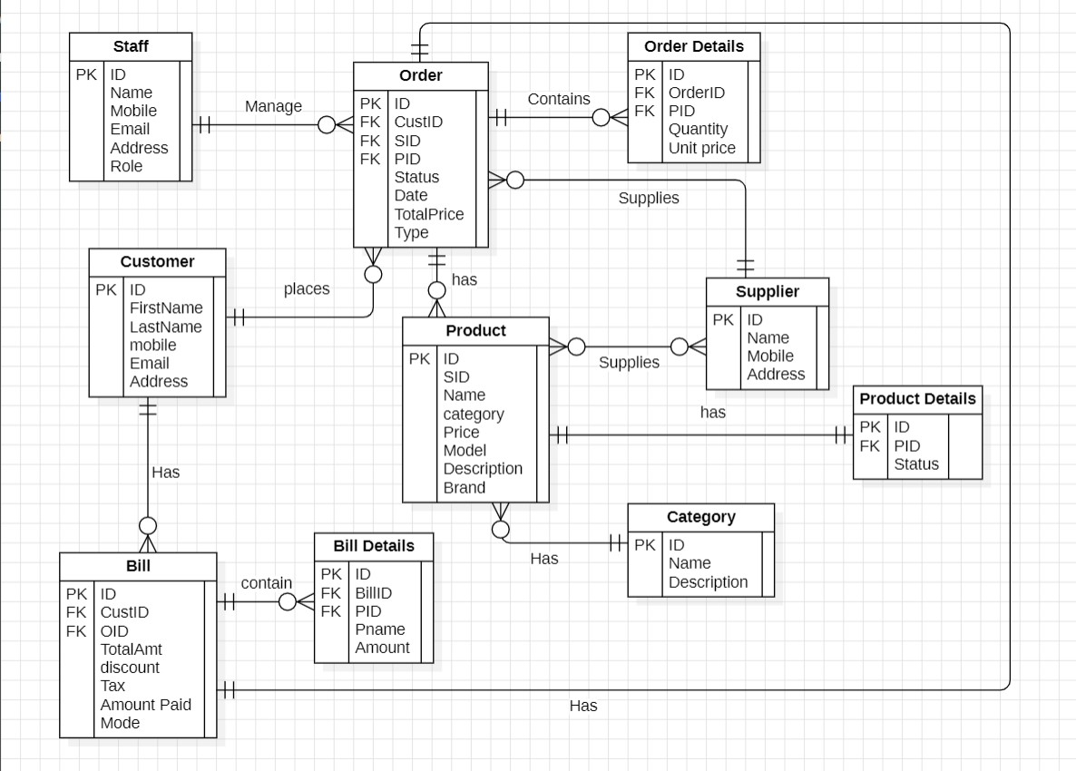

Fig 2: ER Diagram

3.6.2

Use

C

ase Diagram

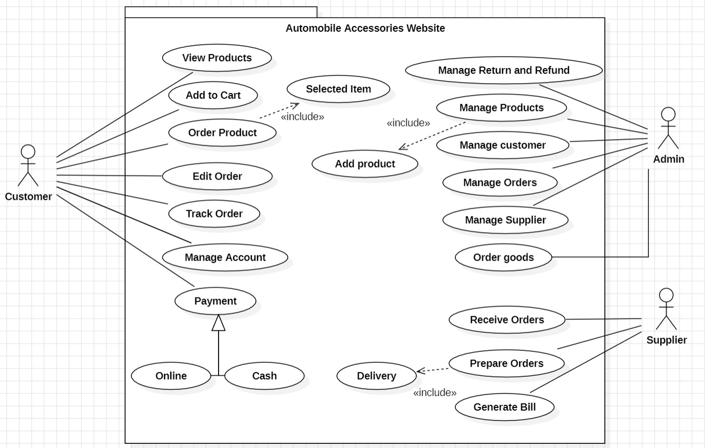

Fig 3: Use Case Diagram

3.6.3

Class Diagram

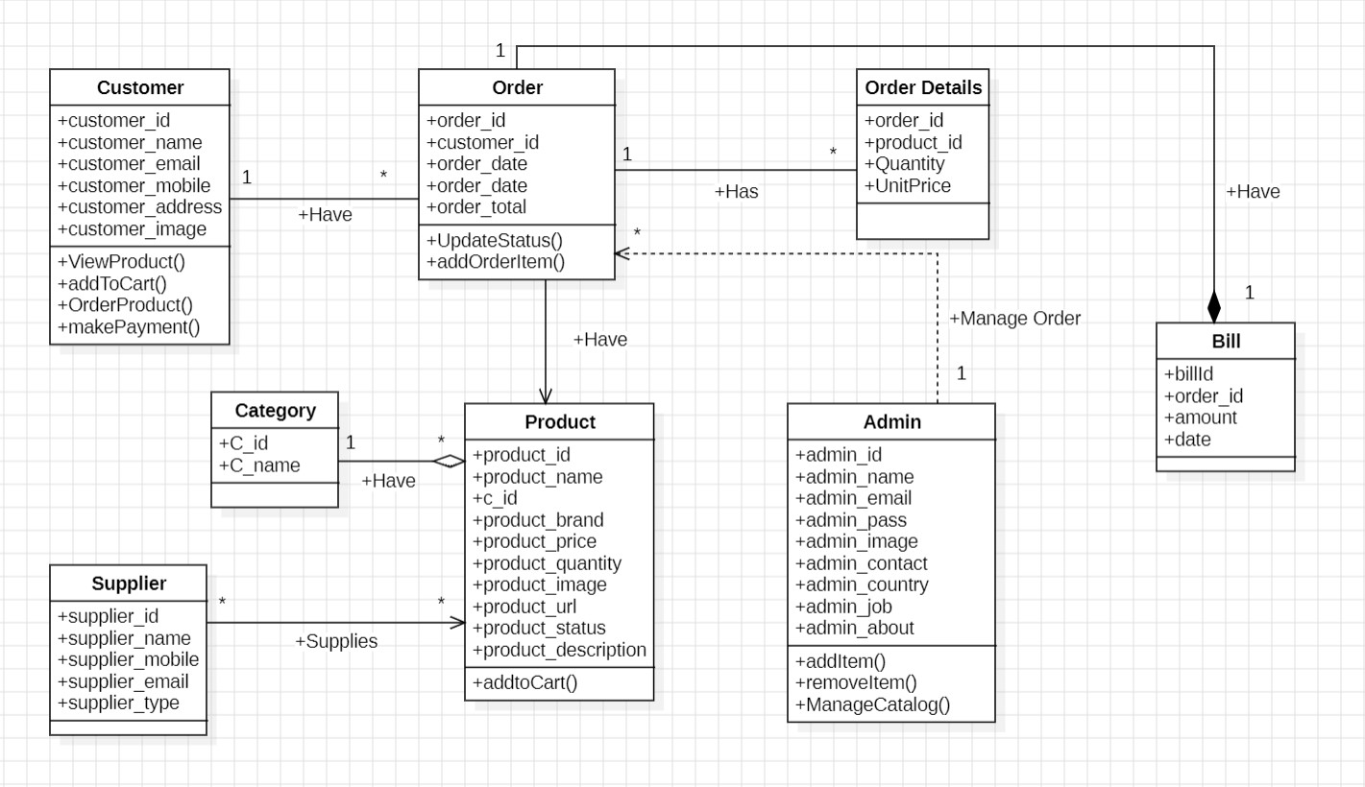

Fig 4: Class Diagram

3.6.4

Sequence Diagram:

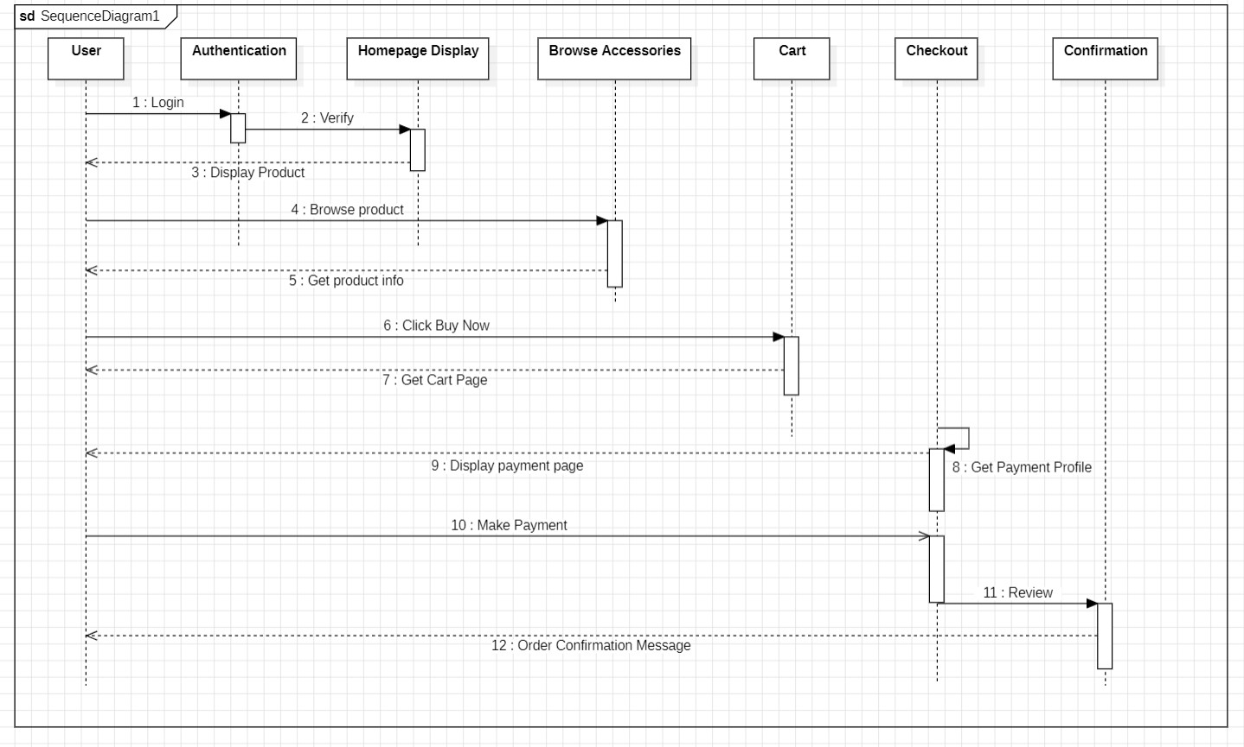

Fig 5: Sequence Diagram

3.6.5

Deployment Diagram:

Fig

6

:

Deployment Diagram

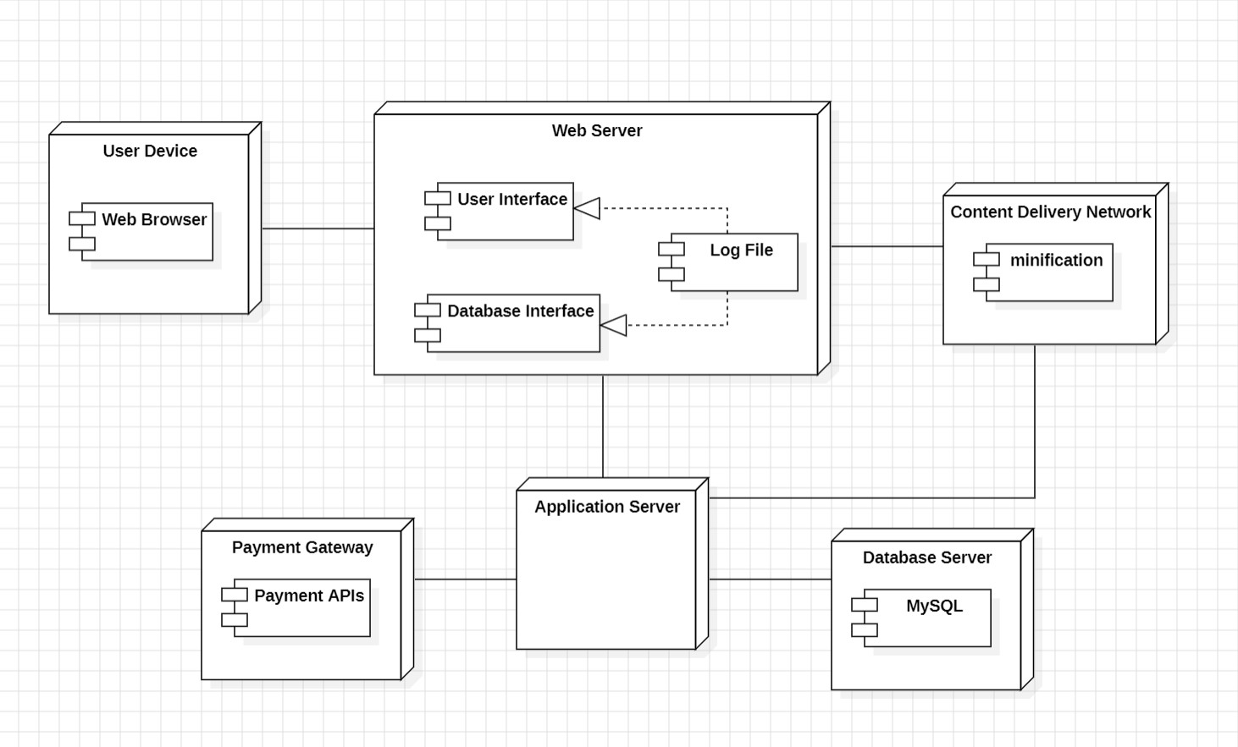

3.6.6

Activity Diagram

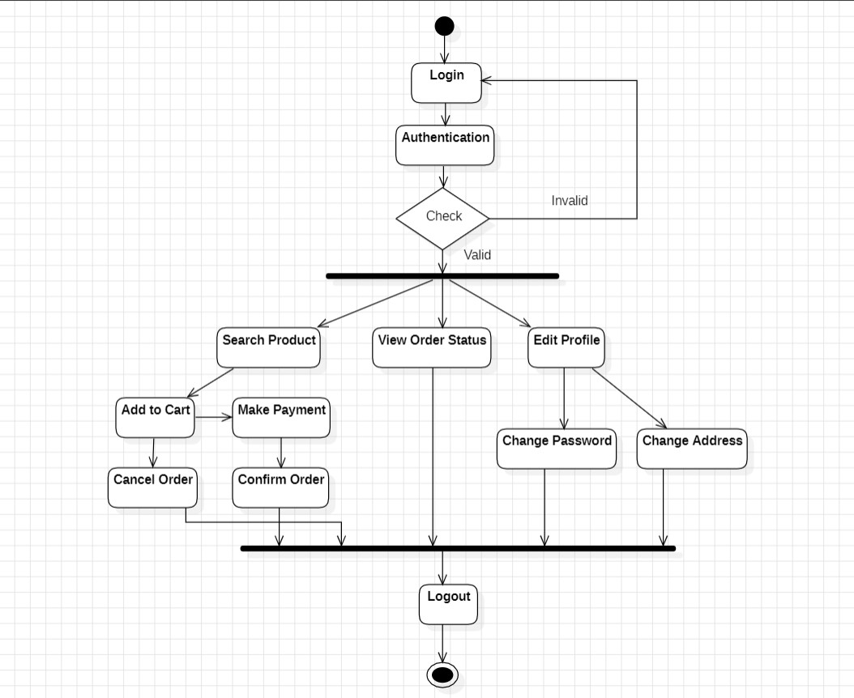

Fig 7: Activity Diagram

## 4. SYSTEM DESIGN

4.1 System Architecture:

The website will follow a three-tier architecture:

* Presentation Tier:

Web-based user interface for customers, suppliers, and administrators.

* Application Tier:

Business logic layer handling user requests, order processing, and interactions with the database.

* Data Tier:

Database to store user information, product details, and order history.

Modules

1. Product Module

This module is responsible for managing the products available on the platform. It includes functionalities related to adding new products, updating existing product information (such as description, price, and availability), categorizing products, and handling product images.

1. Customer Module

The Customer Module focuses on the interactions and activities of the users who are the customers of the system. It handles user registration, authentication, browsing products, adding items to the shopping cart, managing orders, and viewing order history.

1. Admin Module

The Admin Module is designed for administrators or system managers who oversee and control the overall functioning of the system. It includes functionalities to manage users, monitor transactions, handle product management, and generate reports.

1. Supplier Module

This module is dedicated to managing interactions with suppliers of automobile accessories. It involves functionalities related to supplier registration, product supply management, and communication with suppliers.

1. Inventory Module

The Inventory Module is responsible for maintaining accurate records of product stocks and managing inventory levels. It includes functionalities for tracking product availability, updating stock levels, and generating alerts for low stock.

4.2 Data Design (Database tables and database diagram)

1. Login Table:

|  |  |  |  |
| --- | --- | --- | --- |
| **Column name** | **Description** | **Type** | **Constraints** |
| id | Id of user | INT | PRIMARY KEY |
| full_name | Name of User | VARCHAR |  |
| email | Email of the user | VARCHAR |  |
| pass | Password of the user | VARCHAR |  |

1. Customer Table:

|  |  |  |  |
| --- | --- | --- | --- |
| **Column name** | **Description** | **Type** | **Constraints** |
| customer_id | ID of the customer |  | PRIMARY KEY |
| customer_name | Name of the customer | VARCHAR |  |
| customer_Mobile | Mobile number of the customer | LONG |  |
| customer_email | Email of the customer | VARCHAR |  |
| customer_Address | Address of the customer | VARCHAR |  |

1. Product Table:

|  |  |  |  |
| --- | --- | --- | --- |
| **Column name** | **Description** | **Type** | **Constraints** |
| Product_ID | ID of the product |  | PRIMARY KEY |
| Product_Name | Name of the product | VARCHAR |  |
| category_id | Category of the product |  | FOREIGN KEY |
| Brand | Brand of the product | VARCHAR |  |
| Price | Price of the product | LONG |  |
| Quantity | Quantity of the product | INT |  |
| status | Status of the product | VARCHAR |  |

1. Admin Table:

|  |  |  |  |
| --- | --- | --- | --- |
| **Column name** | **Description** | **Type** | **Constraints** |
| admin_id | ID of the admin | INT | PRIMARY KEY |
| admin_name | Name of the admin | VARCHAR |  |
| admin_email | Email of the admin | VARCHAR |  |
| admin_pass | Password of the admin | VARCHAR |  |
| admin_contact | Mobile number of the admin | LONG |  |
| admin_country | Country of the admin | VARCHAR |  |
| admin_job | Type or Job of admin | VARCHAR |  |
| admin_about | Information about admin | VARCHAR |  |

1. Supplier Table:

|  |  |  |  |
| --- | --- | --- | --- |
| **Column name** | **Description** | **Type** | **Constraints** |
| ID | ID of the supplier | INT | PRIMARY KEY |
| Name | Name of the supplier | VARCHAR |  |
| Mobile | Mobile number of the supplier | LONG |  |
| Address | Address of the supplier | VARCHAR |  |

1. Category Table:

|  |  |  |  |
| --- | --- | --- | --- |
| **Column name** | **Description** | **Type** | **Constraints** |
| c_id | Category ID | INT | PRIMARY KEY |
| c_name | Category Name | VARCHAR |  |

4..3 User Interface Design

1

. Home Page

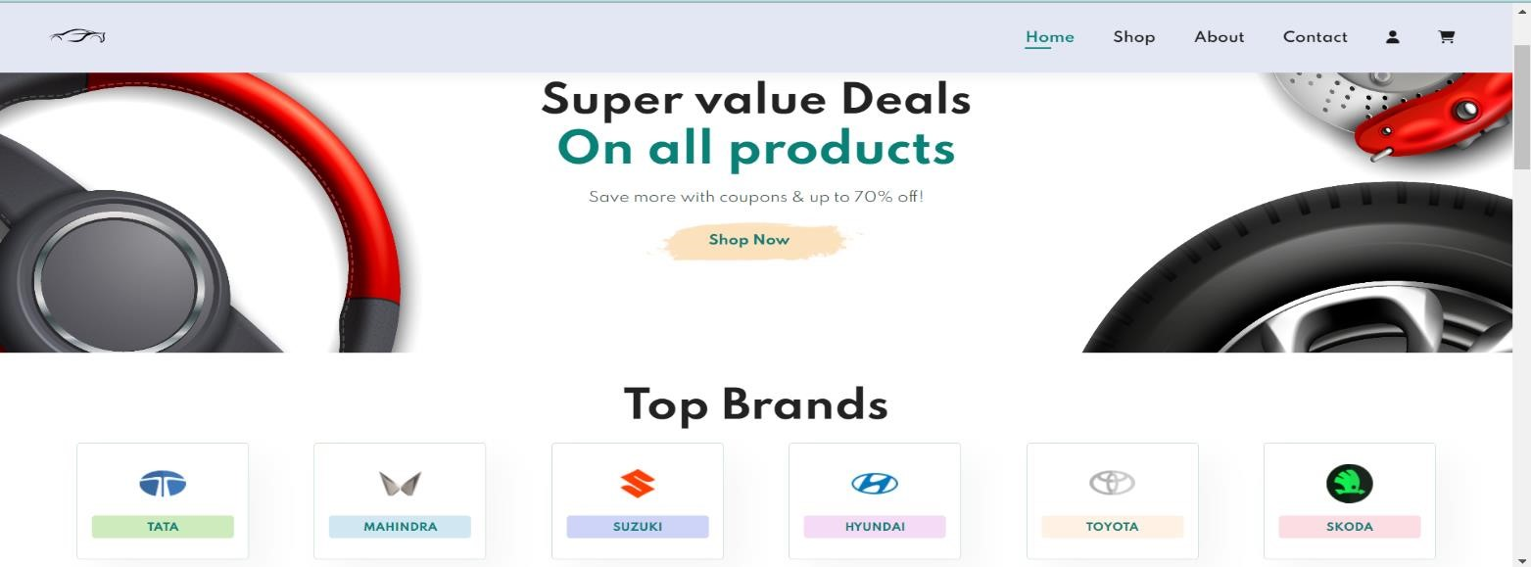

Fig 8: Home Page

2

. Product Page

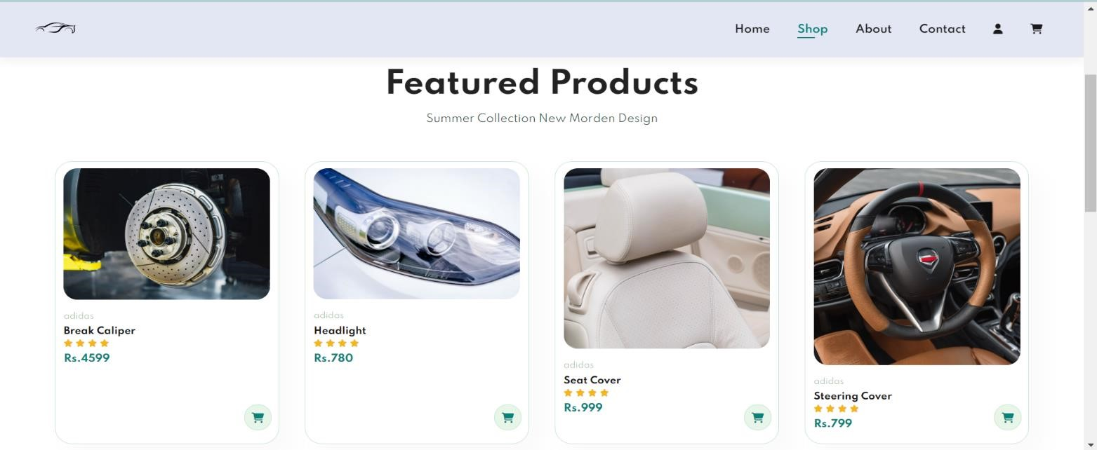

Fig 9: Product Page

3

. About Us Page

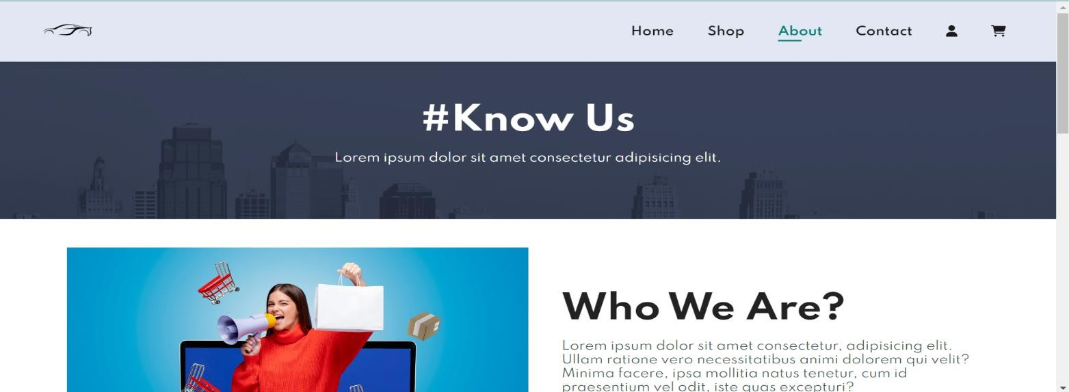

Fig 10: About Us Page

4

. Contact Us Page

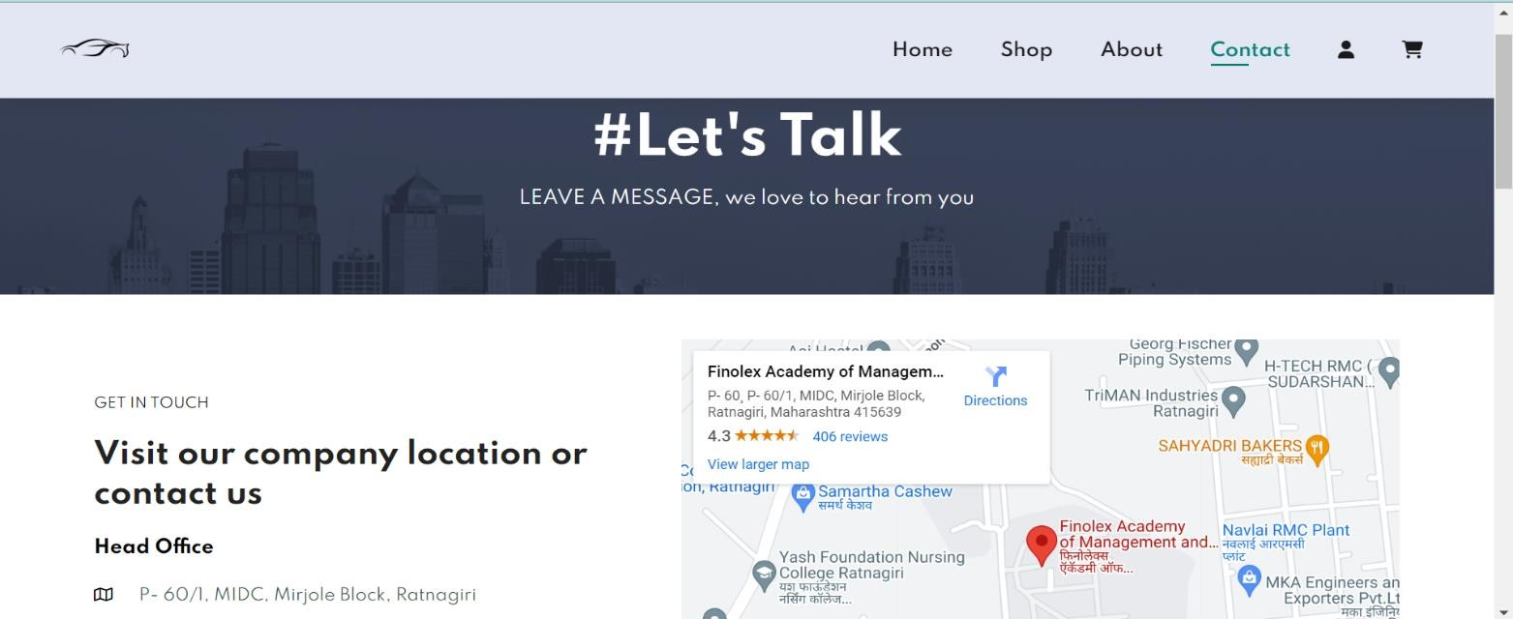

Fig 11: Contact Us Page

5

. Cart Page

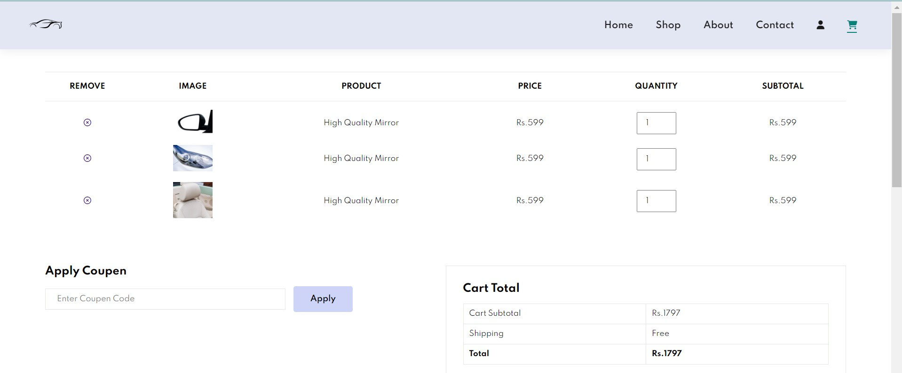

Fig 12: Cart Page

### 4.4 Test Cases

|  |  |  |  |  |
| --- | --- | --- | --- | --- |
| **Sr. No.** | **Possible Inputs** | **Expected Result** | **Actual Result** | **Result (pass/fail)** |
| **1** | Valid Username and correct Password | Login Success Message and Redirect to dashboard | Login Success  Message and  Redirect to dashboard | pass |
| **2** | Valid Username and incorrect Password | Login Failure Message and Reload login Page | Login Failure  Message and Reload login Page | pass |
| **3** | Invalid Username and correct  Password | Login Failure Message and Reload login Page | Login Failure  Message and Reload login Page | pass |
| **4** | Invalid Username and incorrect  Password | Login Failure Message and Reload login Page | Login Failure  Message and Reload login Page | Pass |

**Item:**

|  |  |  |  |  |
| --- | --- | --- | --- | --- |
| **Sr. No.** | **Possible Inputs** | **Expected Result** | **Actual Result** | **Result (pass/fail)** |
| **1** | Enter item id and item name and  click on Add button | Items entered Successfully | Items entered Successfully | Pass |

## CONCLUSION

In conclusion, the development of the Automobile Delivery Website represents a significant leap forward in enhancing the efficiency and convenience of vehicle transportation services. Through userfriendly interfaces, robust backend systems, and seamless integration with various stakeholders, the platform streamlines the entire delivery process. The implementation of real-time tracking, secure payment gateways, and responsive customer support ensures a positive and trustworthy experience for both vehicle owners and transport providers.

As the automotive industry continues to evolve, this website stands poised to play a pivotal role in revolutionizing how automobiles are delivered, fostering a more connected and accessible transportation ecosystem. The success of this project not only marks a technological achievement but also underscores the commitment to advancing the future of automobile logistics.

## BIBLIOGRAPHY

[www.google.com](http://www.google.com/)  [www.youtube.com](http://www.youtube.com/) [www.javatpoint.com/uml-diagrams](http://www.javatpoint.com/uml-diagrams) [www.lucidchart.com/blog/types-of-UML-diagrams](http://www.lucidchart.com/blog/types-of-UML-diagrams) [https://creately.com](https://creately.com/) [www.tutorialspoint.com](http://www.tutorialspoint.com/) [https://stackoverflow.com](https://stackoverflow.com/)  [https://www.c-sharpcorner.com](https://www.c-sharpcorner.com/)